At Home P.E. Scavenger Hunt
Directions: First find the item on the list below them complete the task. Be sure to check them off as you do them. If you move anything please be sure to put it back when you’re done. Have Fun.
Check  Box | Task to complete | Fun Picture
 | Find something you can jump over jump over it 5 times
 | Find something to crawl under (crawl under it 2 times) | 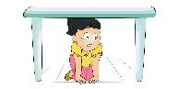
 | Find something yellow, touch it and then do 8 burpees | 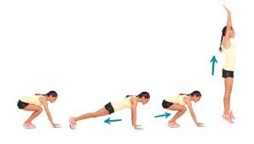
Find something to balance on
(balance for the count of 8 Mississippi)
 | Find something red, touch it and then do 20 jumping jacks | 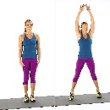
 | Find something to balance on your head, walk from the kitchen to your bedroom | 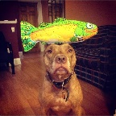
 | Find something to skip around (5 times)
 | Find the room in your house that has the most pillows, do 10 shoulder touches in that room | 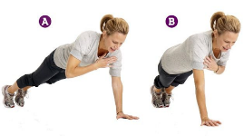
 | Find a chair - sit in the chair and stand up  15 times in a row | 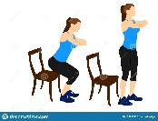
Turn on your favorite song and dance or exercise/move
for the entire song
 | Go to your favorite room in your house and do YOUR favorite exercise 10 times | 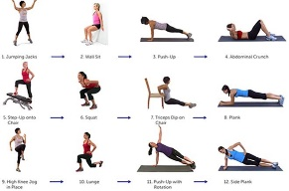
 | Find each person in your house and give them a compliment (example-Mom, you did a great job helping me with my school work today, Dad, breakfast was really good this morning thank you for making it for me)

